Root Locus;

1
G(s)= -----------------------
s^3 + 10.3 s^2 + 11.7 s

Root Locus Çizimi:

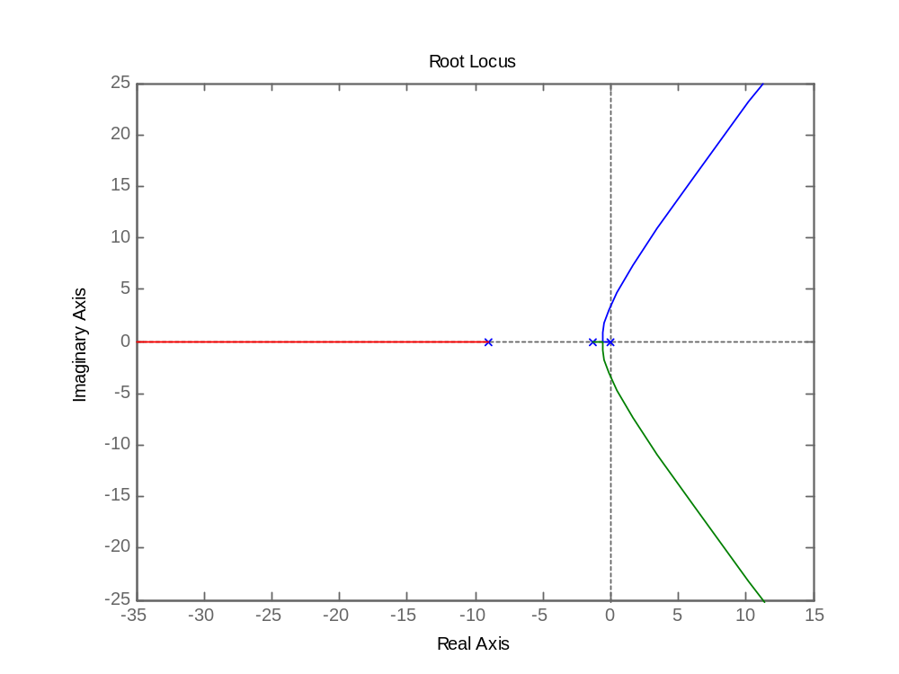

MATLAB kodu:

>> num=[0 0 0 1]

num =

0 0 0 1

>> den=[1 10.3 11.7 0]

den =

1.0000 10.3000 11.7000 0

>> GS=tf(num,den)

Transfer function:
1
-----------------------
s^3 + 10.3 s^2 + 11.7 s

>> rlocus(GS)

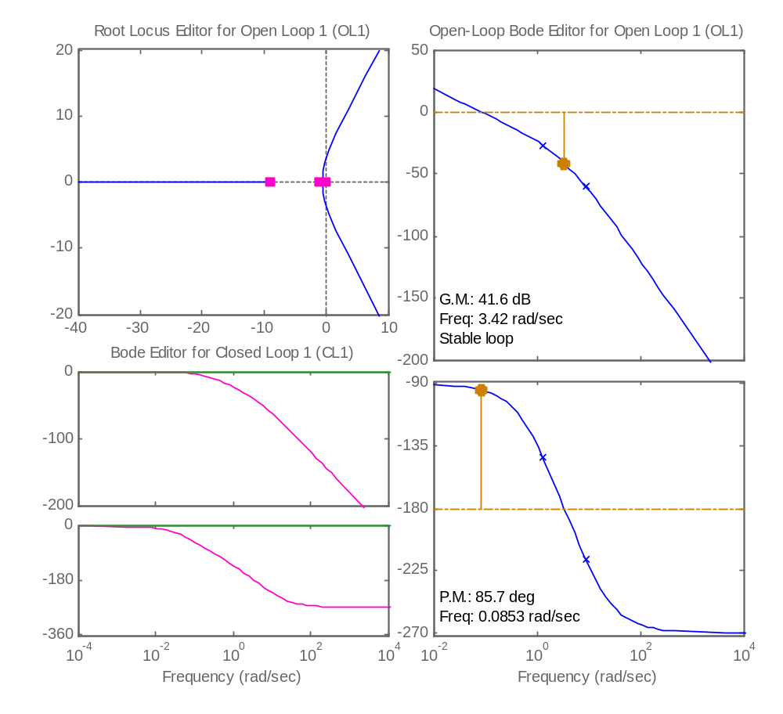

SISO TOOL

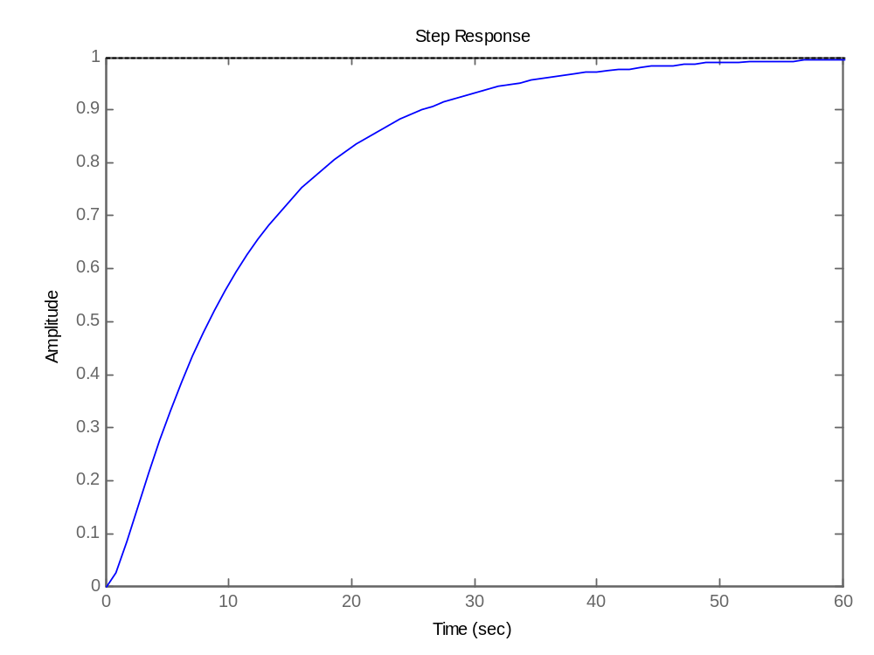
STEP RESPONSE

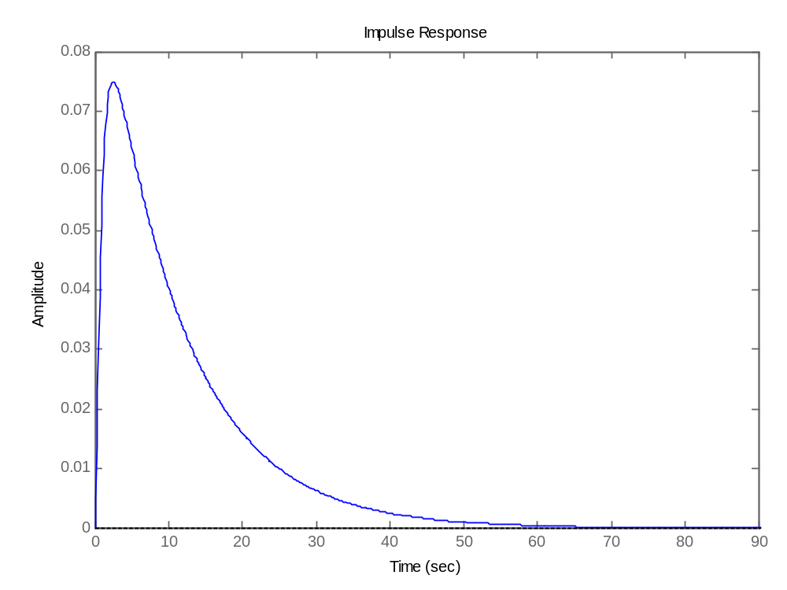
IMPULSE RESPONSE
Root Locus-Lag (Gc(s) için)

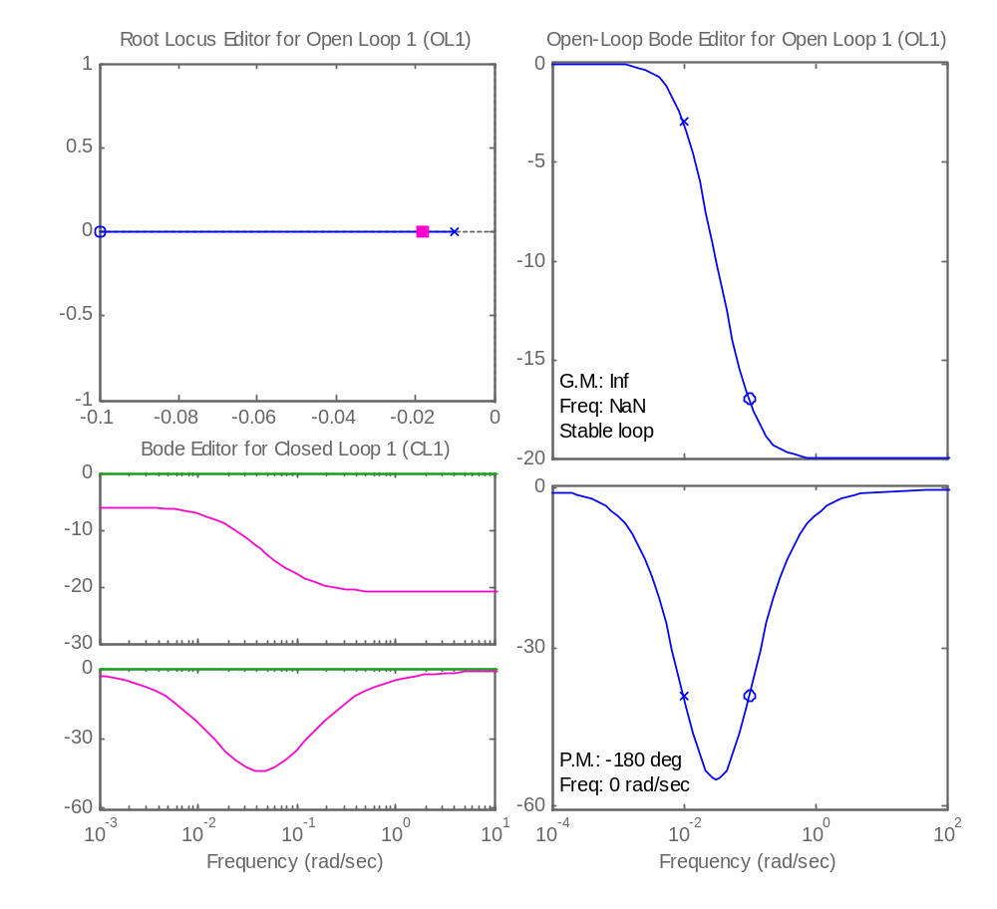
SISO TOOL

MATLAB kodu;

>> num=[0.1 0.01]
num =
0.1000 0.0100
>> den=[1 0.01]
den =
1.0000 0.0100
>> GCS=tf(num,den)

Transfer function:
0.1 s + 0.01
------------
s + 0.01

>> rlocus(GCS)
>> sisotool
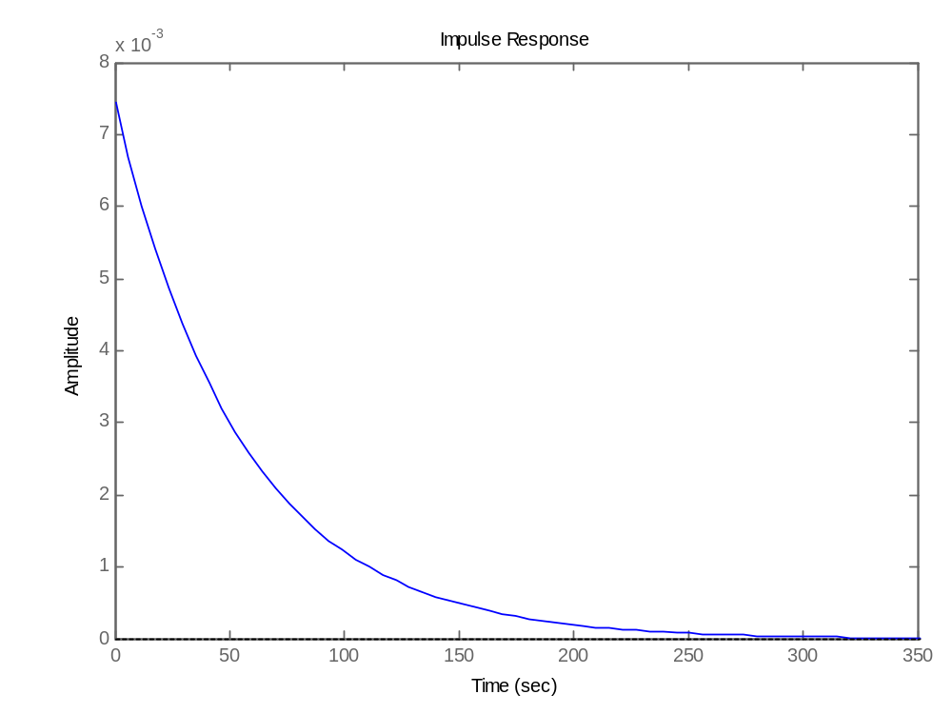
IMPULSE RESPONSE

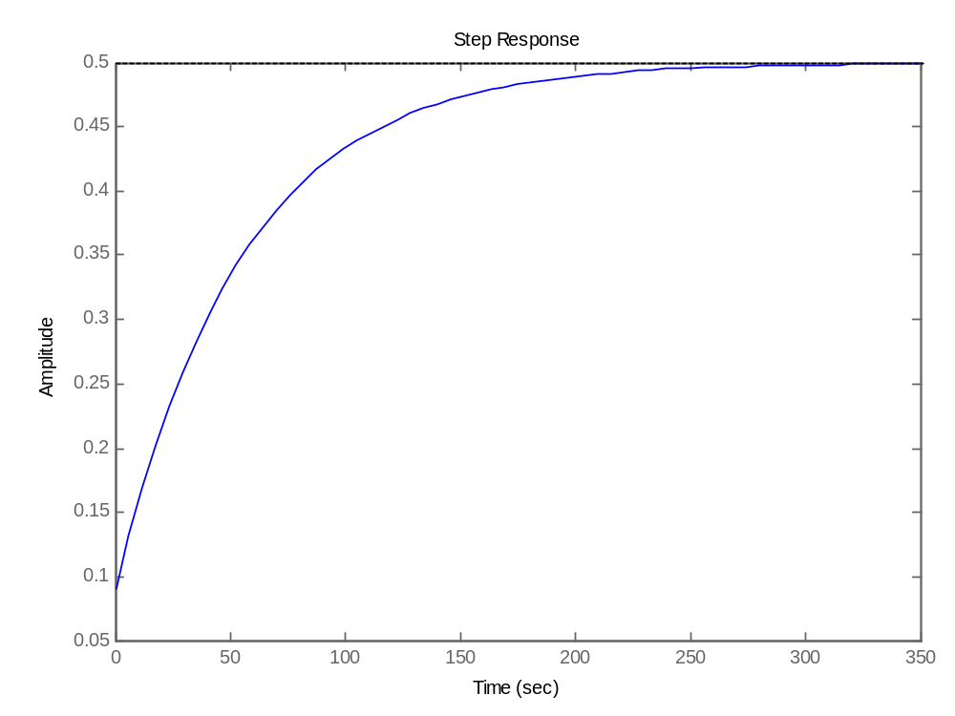
STEP RESONSE
BODE LEAD:

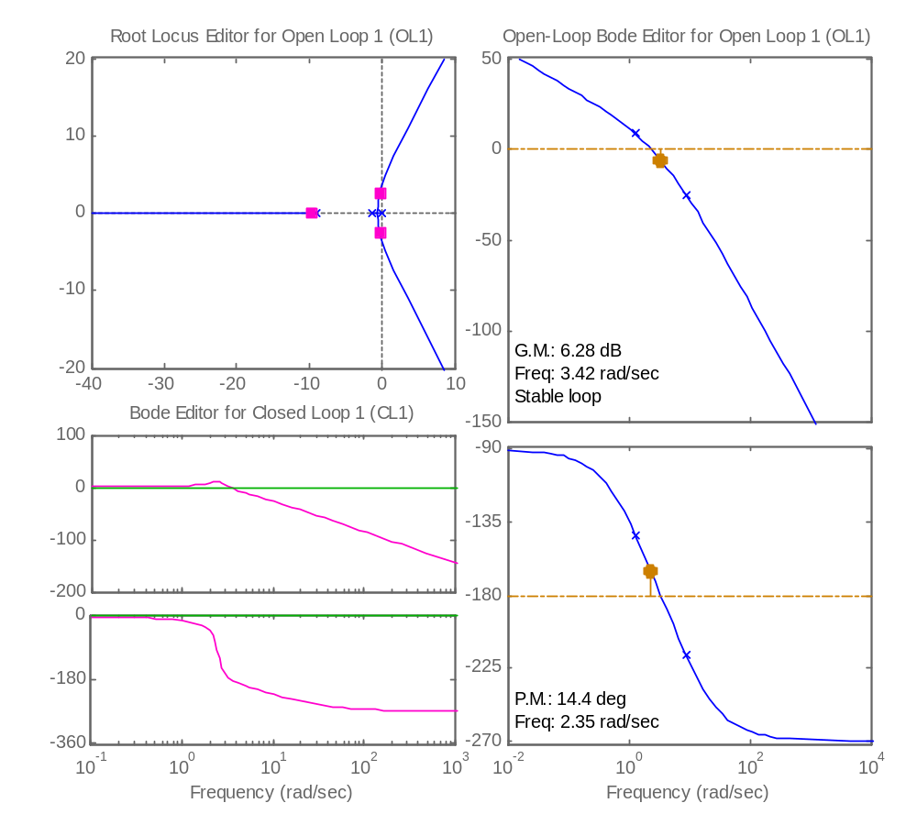
SISO TOOL

MATLAB kodu:

>> K=58.5;
>> num=[0 0 0 K];
>> den=[1 10.3 11.7 0];
>> GS=tf(num,den)

Transfer function:
58.5
-----------------------
s^3 + 10.3 s^2 + 11.7 s

>> bode(GS)
>> sisotool
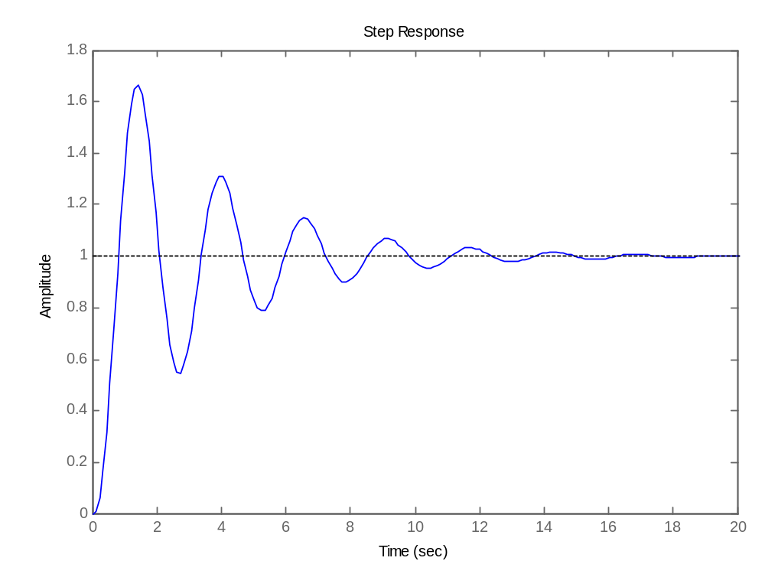
Step Response

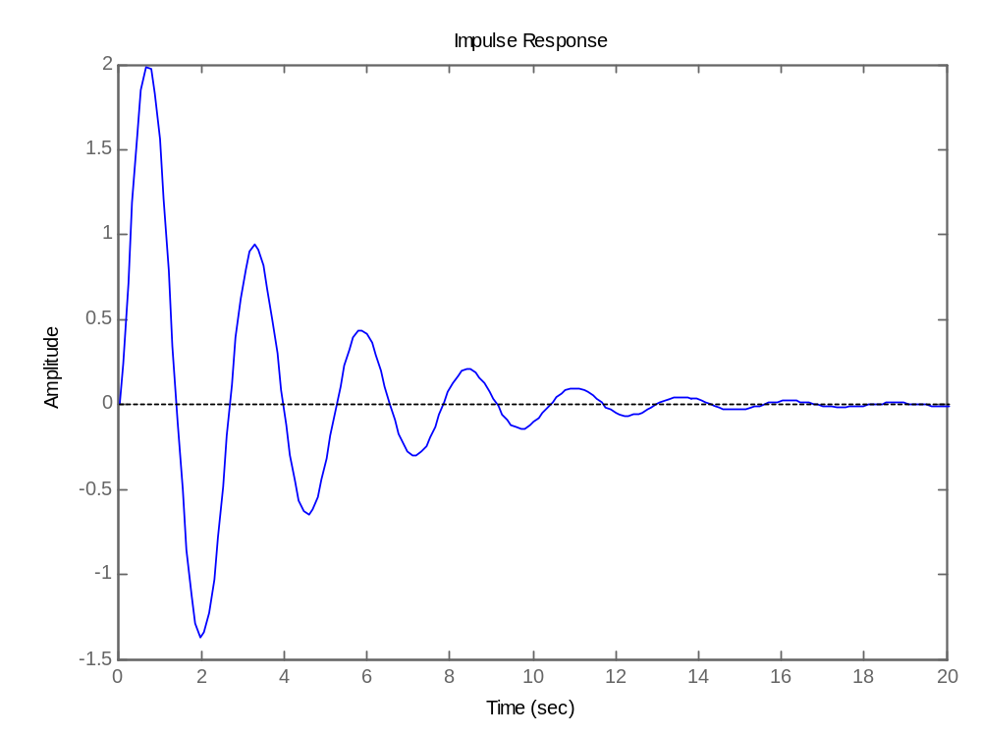
Impulse Response
BODE PI:

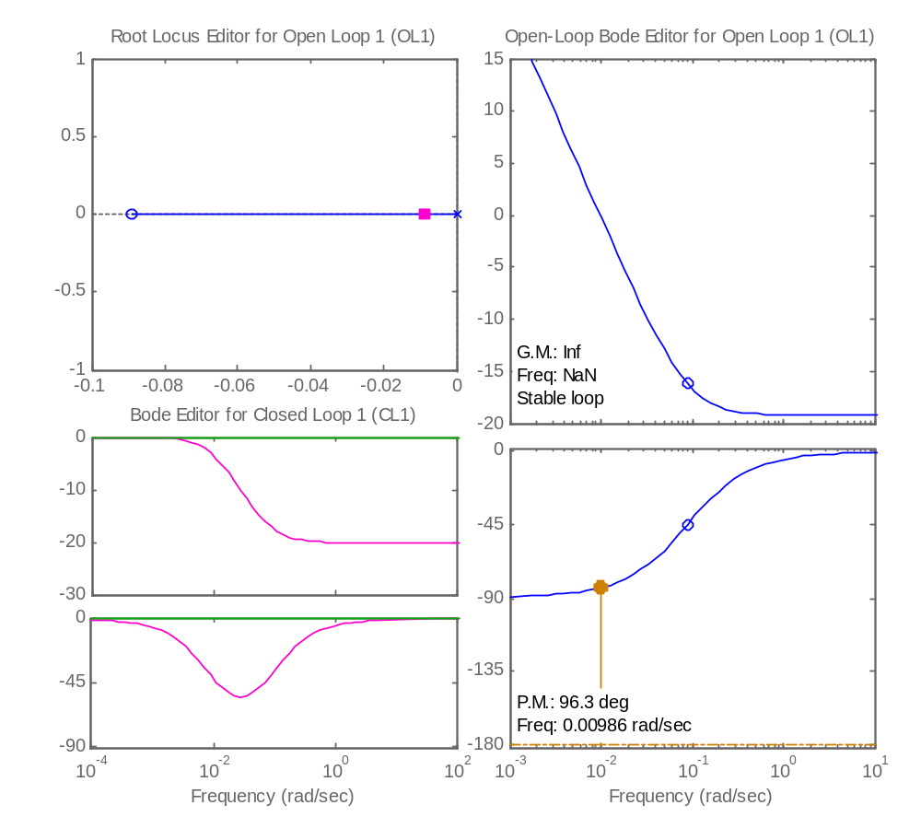
SISO TOOL

MATLAB kodu:

>> num=[0.11 0.0098];
>> den=[1 0];
>> CS=tf(num,den)

Transfer function:
0.11 s + 0.0098
---------------
s

>> rlocus(CS)
>> sisotool
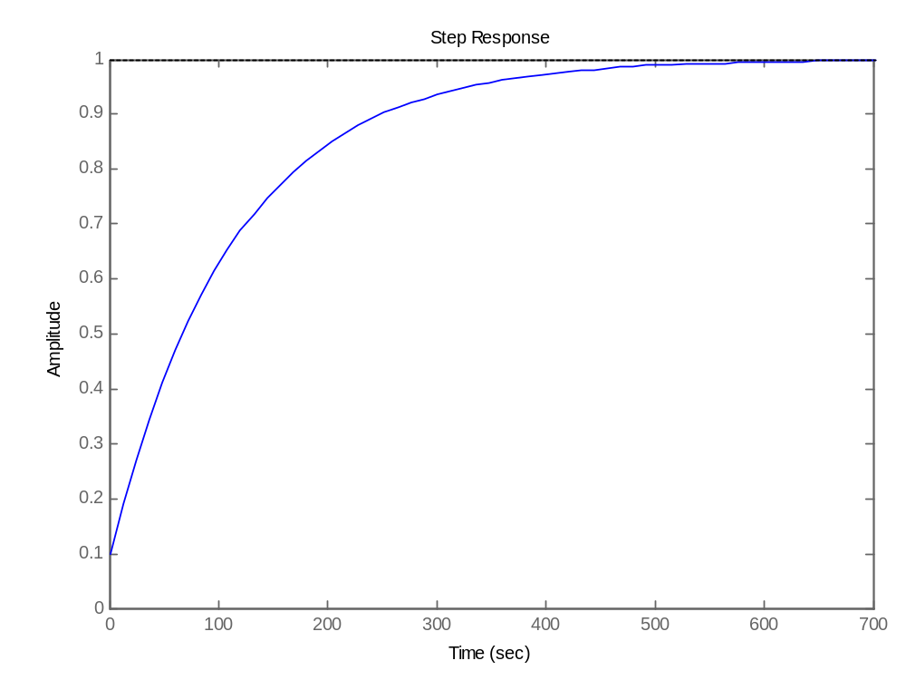
STEP RESPONSE

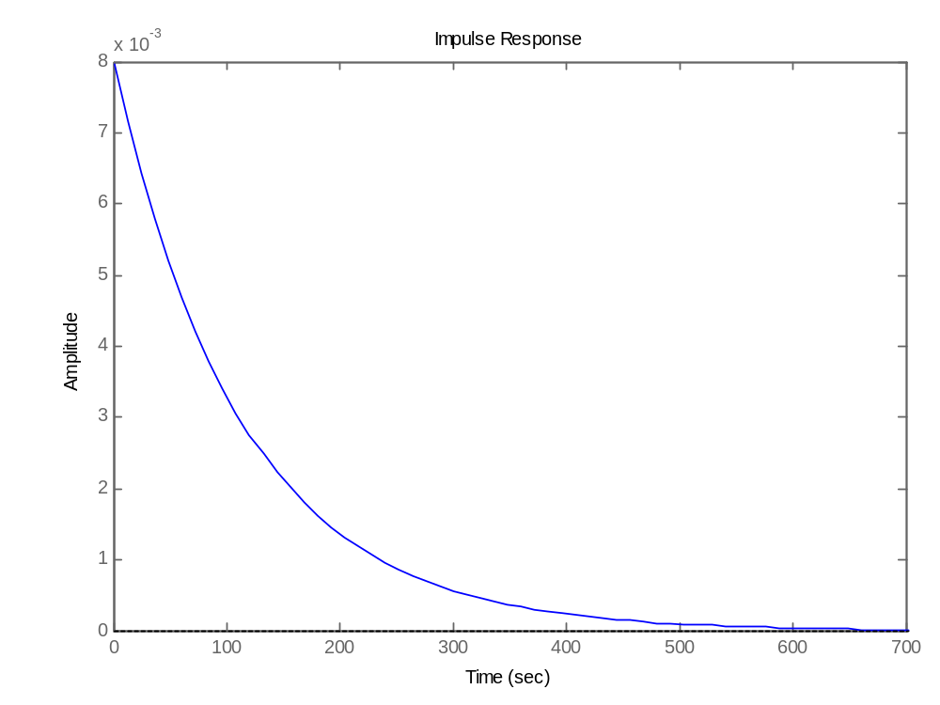
IMPULSE RESPONSE

